Appendix User Experience and Error Handling Examples

1. Loading state for chatbot input text area and buttons

Not Loading:

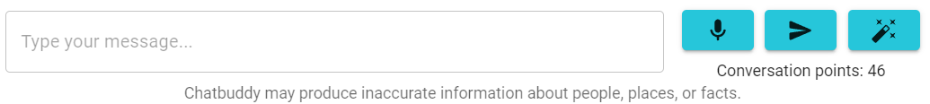

Loading:

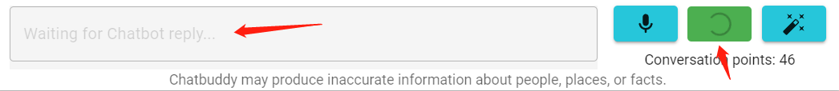

2. Loading state for chatbox:

Not Loading:

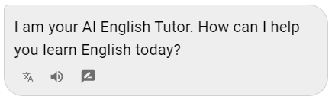

Loading:

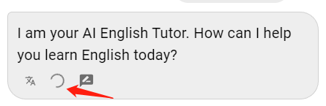

2. Tooltip for new topic button and create button

 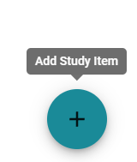 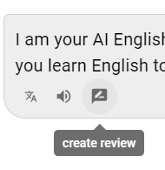

3. Form validation

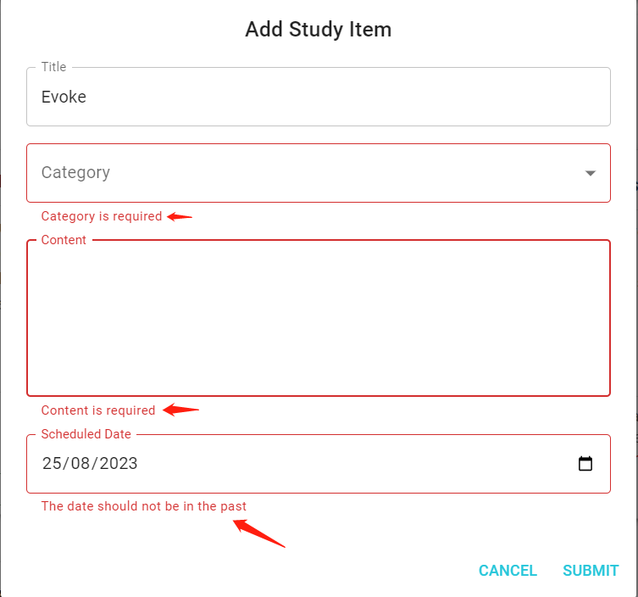

4.snack bar at the left bottom of the screen to show error and success message:

 